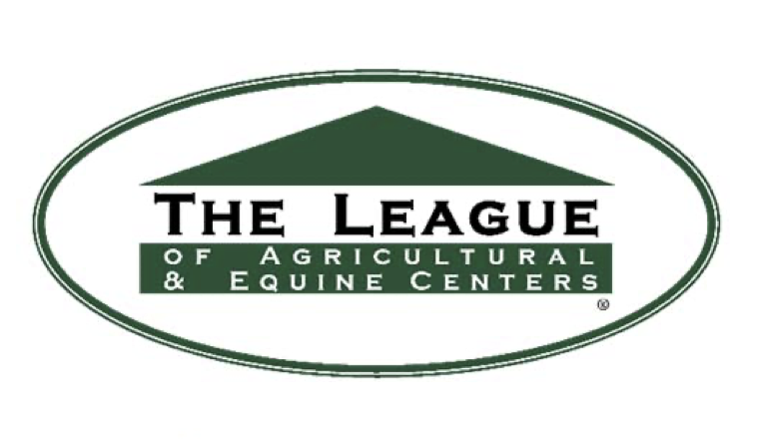
HALL OF FAME AWARD REQUIREMENTS AND NOMINATION FORM
The League of Agricultural and Equine Centers Hall of Fame Award is in recognition of devoted and invaluable service rendered to the equine facility management industry. Not more than one individual League member will be inducted into The League Hall of Fame annually. The induction will occur at the League’s Annual Symposium and the inductee shall receive an appropriate award befitting this recognition.
Eligibility:
- The Nominee may be living or deceased.
- The Nominee shall have served as a manager or CEO of a League member facility during
his/her career. A candidate currently not managing is eligible for ten (10) years following
his/her separation from the manager’s or CEO’s position.
- The Nominee shall have been identified with the equine facility management sector for a
minimum of ten (10) years.
- The Nominee shall have contributed to the equine facility industry and The League in the
fields of leadership and education for which the value can be demonstrated.
- The Nominee shall have been consistent in attending League events.
- The Nominee shall have actively participated in the affairs of The League.
- The Nominee shall have demonstrated distinguished achievement, which may include
significant contributions to the knowledge and literature of the facility management industry, design of related materials, management processes, technical processes or outstanding service to related organizations that serve the equine facility management profession.
- A League Board Chair shall not be considered for induction until two (2) years after his/her term expires.

Nomination Requirements:
Each nomination submitted will be eligible for consideration for a three year period. As an example, a nomination submitted for the 2019 award will remain in the nomination pool for 2020 and 2021 unless the nominee is inducted. No further action will be required by the Nominee or the person submitting the nomination. However, nominees may update or modify their nomination form prior to the annual submission deadline e.g., 2020 and 2021.
Nominations shall be submitted by any active League member by completing a nomination form. A member may nominate himself/herself or nominate another person. Nominations shall state the reason for proposing the nominee along with a record of his/her professional and personal achievements. Should
the person making the nomination not be the nominee, then that person may solicit from the nominee supporting documentation to support the nominee’s worthiness to receive the award.
Attachments to the nomination form must be submitted in a Word document or as a PDF attachment.
The nomination form and supporting documentation must be received by the League Executive Office no later than September 30.
Finalists may be asked to submit additional documentation.
Selection:
Completed nomination forms will be reviewed and evaluated by the League’s Awards Committee. The Awards Committee shall be led by the League Board Chair with two additional board members. Should any League board member be nominated for the award, they must recuse themselves from the selection process. Recommendations by the Awards Committee will be presented to the full Board of Directors for final selection. No more than one award will be presented each year. The Board of Directors reserve the right, in its sole discretion, not to issue the award in any year if it is determined no nominee submitted reaches the level of worthiness expected.
Deadline for application submission is September 30. The induction and award will be presented at The League’s annual symposium the following January.

